**Section 1:**

Course preview , where are the resources , Github , how to utilize the course etc.

**Section 2:**

Theory of what a rest service is.

**Section 3:**

**Lecture 10,11,12:** How to setup spring boot project

**Lecture 13** ? How REST is mapped , how URI is mapped

**Lecture 14,15:** Creating Hello world, add bean to it.

**Lecture 16:** Theory of springs

What is dispatcher servlet? ? Servlet that handles http requests ,it uses FRONT controller design pattern.It knows all the mapping present .

Who is configuring dispatcher servlet ? ? SpringBootAutoConfiguration

What does dispatcher servlet do ? ? handles all the requests as per the mapping

How does the HelloWorldBean gets converted to Object ? - Jackson2Mapper bean converter.

Who is configuring the Error mapping ? ? SpringBootAutoConfiguration

**Lecture 17:** Path Variable example

**Lecture 18:** Create User Bean/Service ,@component

**Lecture 19:** Implementing GET method for User Resource ,@RestController

**Lecture 20:** Implementing POST method for User Resource

@RequestBody ? maps the values from an http request body to the object

Invoke POST request? POSTMAN( or any REST Client)

**Lecture 21:** *Enhancing POST method for to return correct status /return type

*http best Practices ? return correct status for correct operation/infformation.

URI location=ServletUriComponentBuilder.fromCurrentRequest()

.path(/{id})

.buildAndExpand(savedUser.getId())

.toUri();

return ResponseEntity.created(location).build();

**Lecture 22:** Exception handling.

*To send a more fitting response use: @ResponseStatus(HttpStatus.NOT_FOUND)

* Best practices is :to return 404 if resource not found rather than 500.

i.e to return suitable status rather than any error or non 200 status.

**Lecture 23:** Exception Handling: Generic style.

? define the response structure(generally a class containing exception timestamp,message,category,severity,etc)

? ResponseEntityExceptionHandler:An abstract class that provides basic exception handling methods. Extend this class, override methods as shown below.

@ControllerAdvice ? This class is now treated as exception handler for all the controllers defined in this app.

@RestControllers ? Tells Springs that this class is a Controller

extends ResponseEntityExceptionHandler? to inherit the default methods & override as needed.

@ExceptionHandler(XXX.class) ? fire this annotated method when exception of the class xxx.class is thrown.

ExceptionResponse ? Org based exception structure.Throw this when exception occurs.

@ExceptionHandler(UsernotFoundException.class) ? Custom exception class that is thrown when a user is not found from the UserService.

**Lecture 24:** Implement Exception Handling for POST method.

**Lecture 25:** Implement DELETE method.

**Lecture 26:** Validation Framework .

The response is 400 ? but it doesnt tells what went wrong. Thus we need to provide a customized message.i.e override the handleMethodArgumentNotValid() from ResponseEntityExceptionHandler.class in our CustomizedResponseEntityExceptionHandler.java

Exceute the request & see the message.

There is too much of details , so we can customize the message by :

? Providing message at user entity.

? remove ex.getBindingResult().toString() with Validation Failed

Execute the REST request again, see the message outputs & the @nnotated message.:

Various type of validation present are listed under: javax.constraints package of

validation-api-1.1.0.Final.jar & is implemented in hibernate-validator-5.4.jar. They are defined as spring web started web dependency, thus we get these jars when we import the project.

**Lecture 27: HATEOAS**

Hypermedia As The Engine Of Application State (HATEOAS) is a component of the REST application architecture that distinguishes it from other network application architectures. It mandates a service should provide information on how to access the resource.

Ref: https://spring.io/understanding/HATEOAS

Response = Response + Link to other useful resource.

**Lecture 28:** Advanced REST using Spring ( Internationalization, Content Negotiation,Documentation,Springs Actuator,

**Lecture 29,30:** INTERNATIONALIZATION (i18n)

how to achieve this :

Configure LocaleResolver

set default Resolver

Set ResourceBundleMessageSource

Use Autowiring to get the MessageSource

1) Create message resources

Add MessageResourceBundles( message.properties, message_fr.properties.

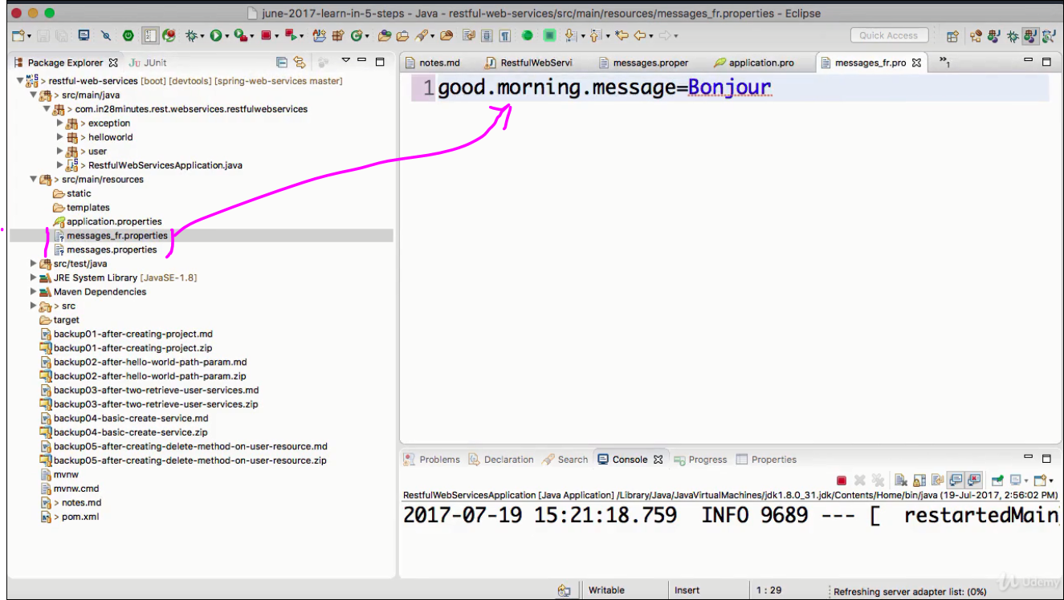

2)Add LocaleResolver & resourceBundleMessageSource to Spring Application

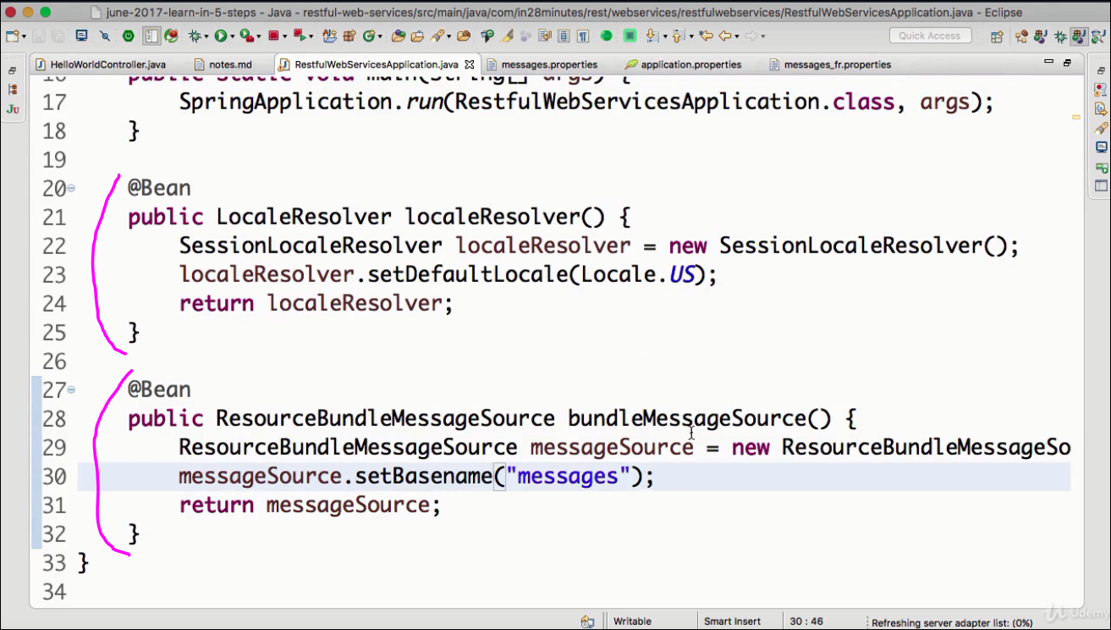

. Note

messageSource.setBaseName(“message”) ==> our messages are stored in message* files.

I.e message.properties, message_fr.properties,message_in.properties etc .

3) Update Controller to use the resource bundle

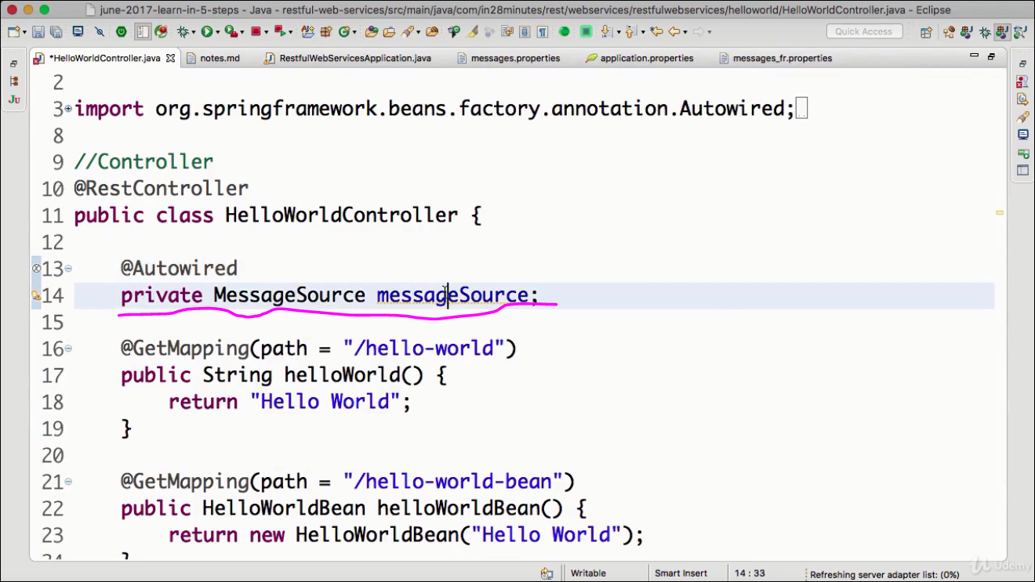

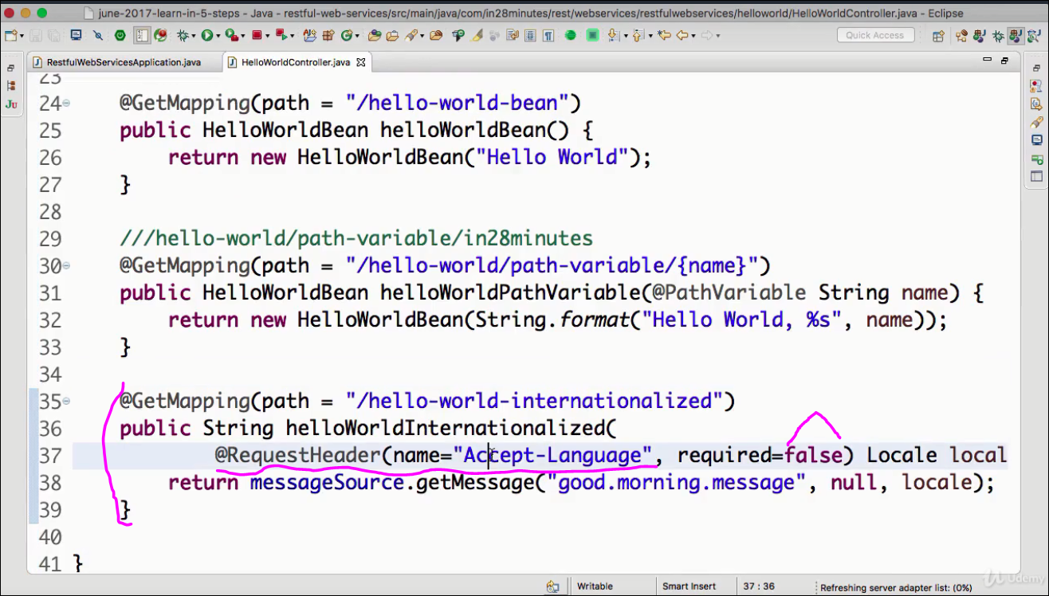

@ResourceHeader(name=Accept-Language,required=false) Locale locale

If the header attribute Accept-Language is present take the locale preference from here ,also required=false=> if not present take default locale.

Test from postman:

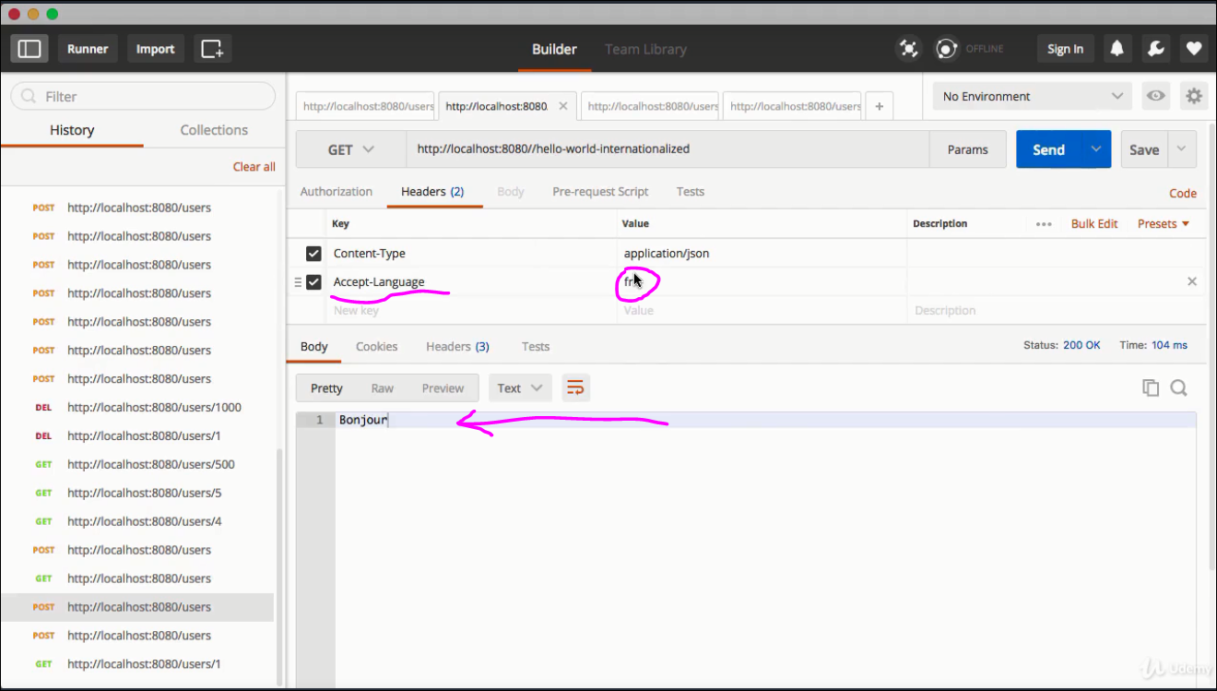

FIX-1 (needs FIX-2 as wel)

Now we have added to the method , its a pain to add it to every method. So instead of picking it from the Accept-Language header lets pick it from LocaleContextHolder. That way we need not pass the Accept-language header always

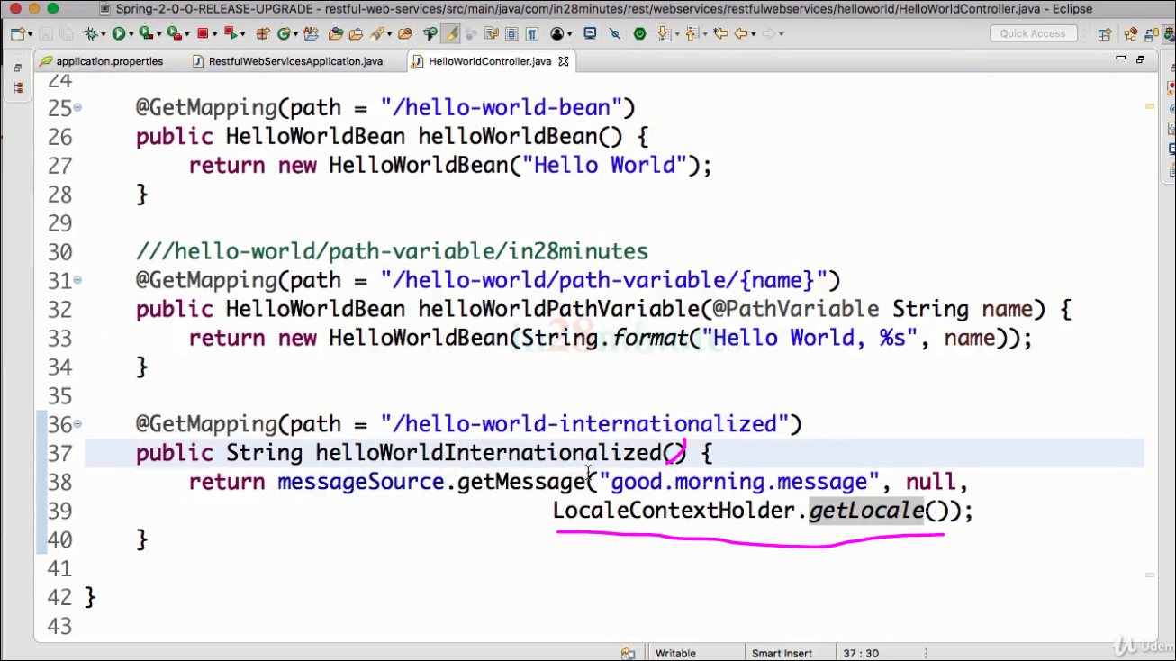

FIX-2

Instead of SessionLocaleResolver we can use AcceptLocaleResolver , this enables SPRINGS to lead locale preference from Accept-Language header. If it is not here , it picks the default.

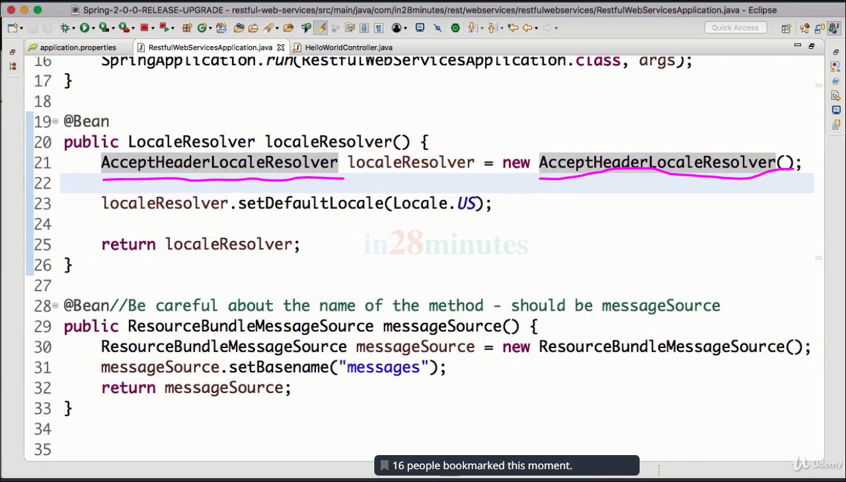

FIX-3: The messageSource() can be removed from RestfulWebServiceApplication.java & done in the message.properties directly as follows:

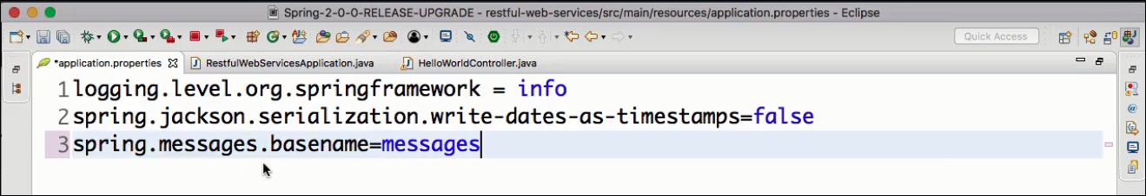

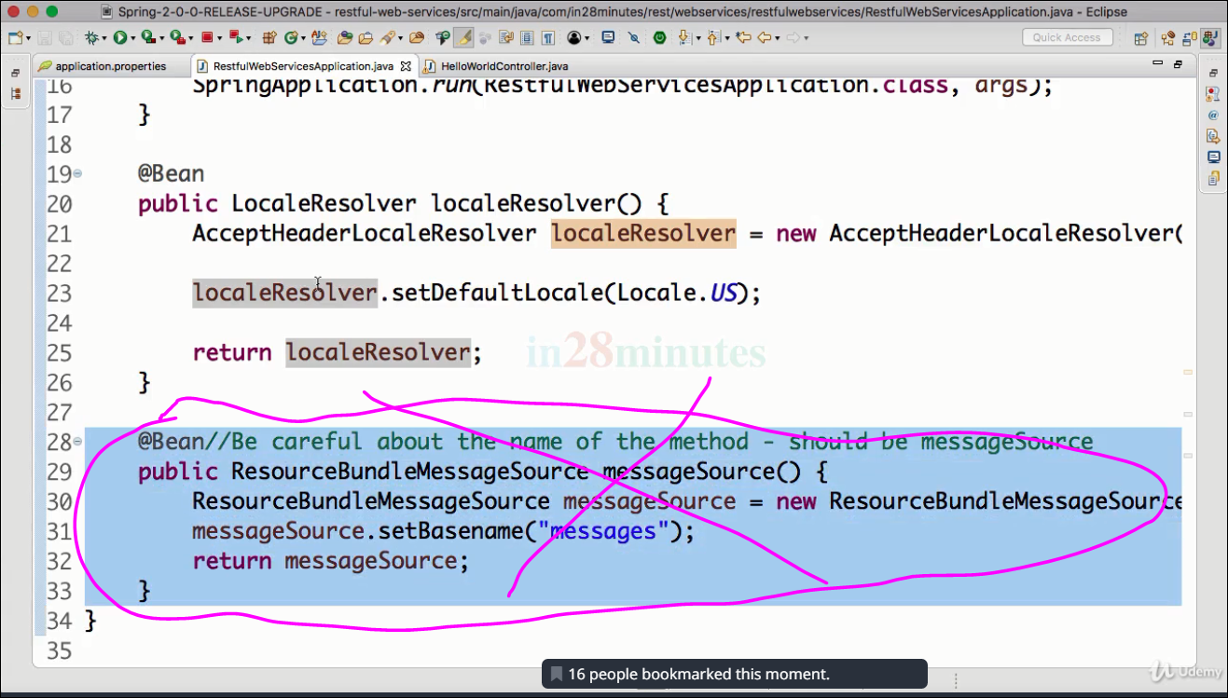

restart the application & test in POSTMAN client.

**Lecture 31: Content Negotiation**

For GET Request

1. **Add the below dependency to the pom**

<dependency>

<groupId>com.fasterxml.jackson.dataformat</groupId>

<artifactId>jackson-dataformat-xml</artifactId>

<version>2.8.5</version>

**</dependency>**

1. **send in header Content-type: application/xml in the POSTMAN client**

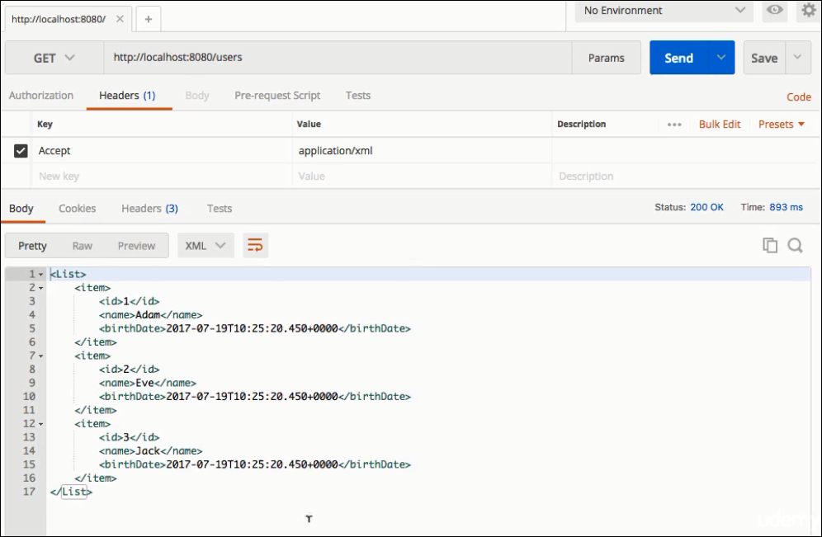

**For POST request:**

1. In Header put the below :

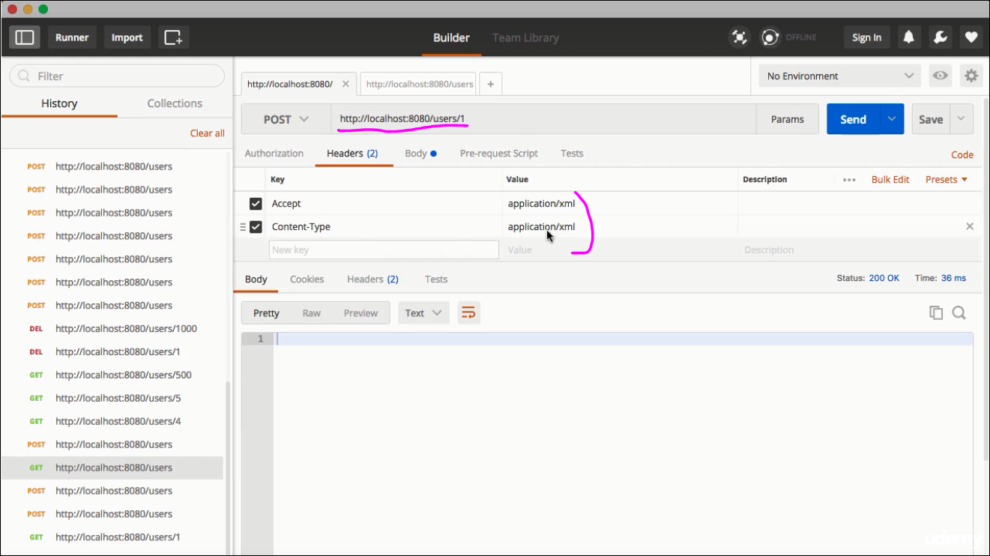

1. In Body put the below & test:

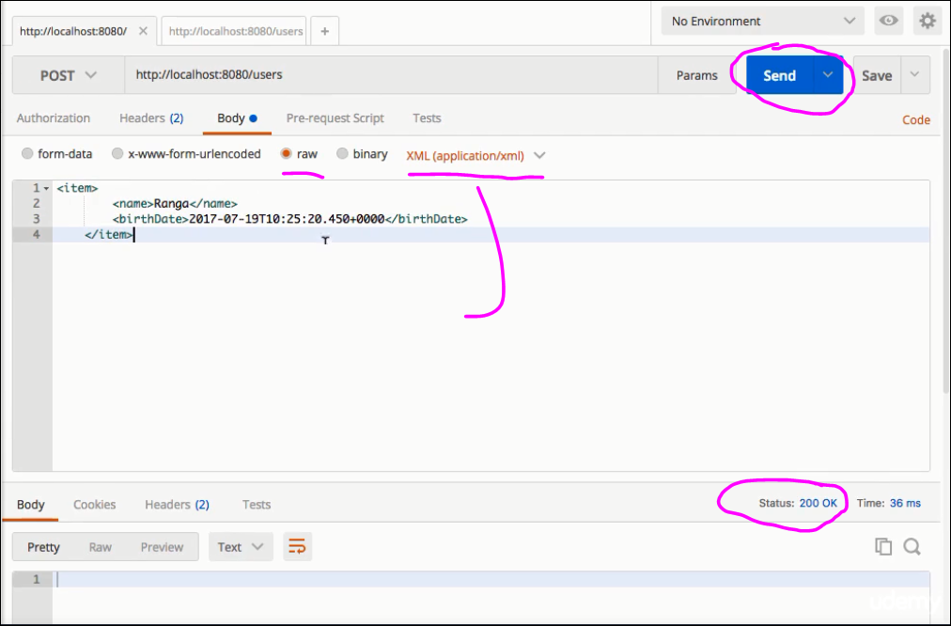

**Lecture 32,33,34: Swaggar Documentation**

1. Add Swagger dependency in the POM.xml

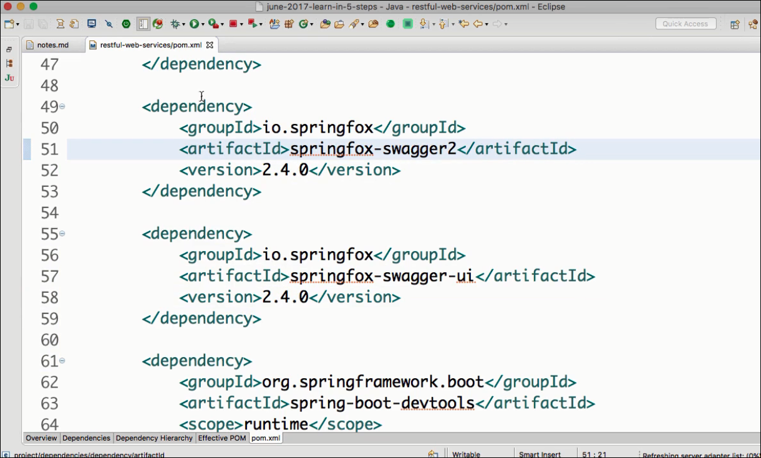

1. Add the Swagger Configuration

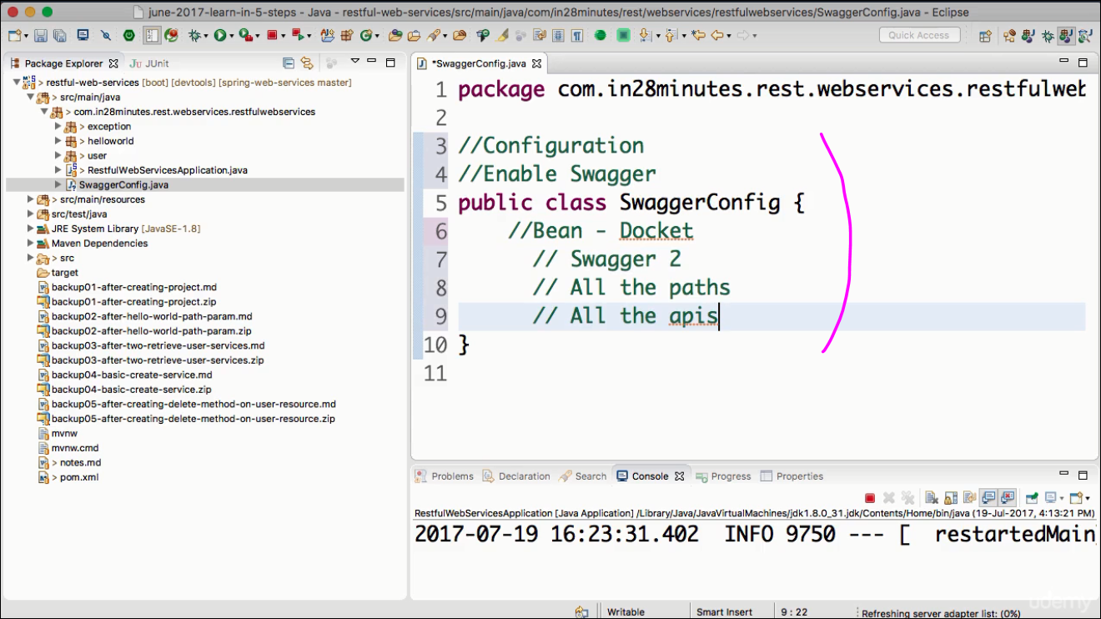

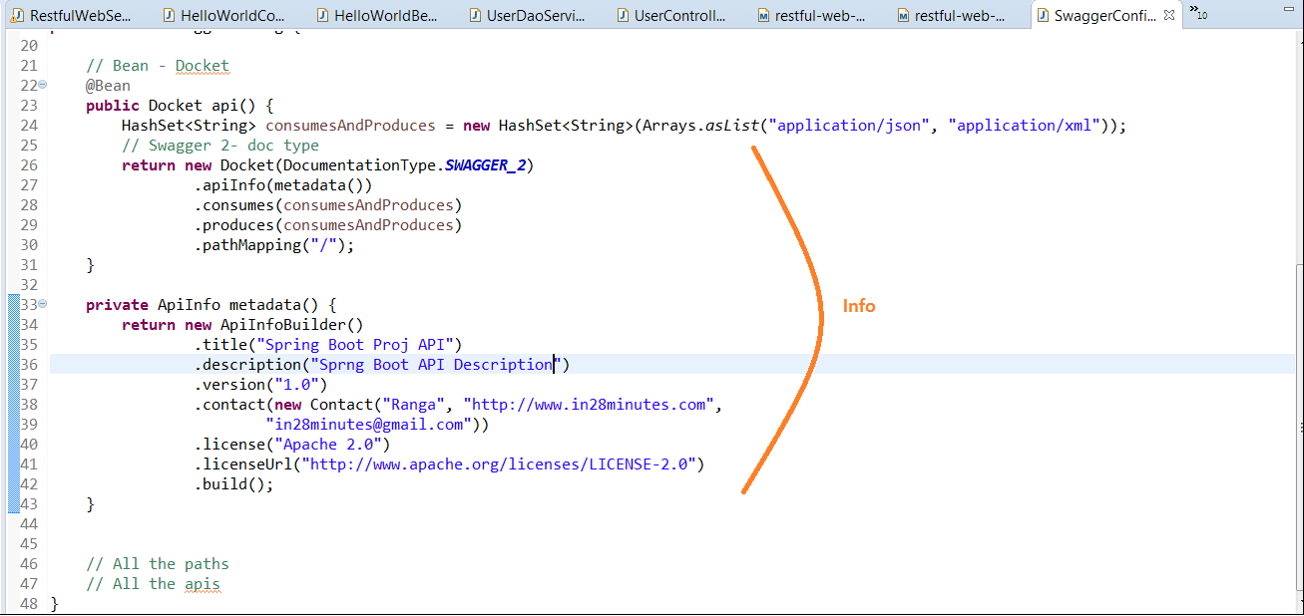

1. Check the output at the below URL:

<http://localhost:8080/v2/api-docs> → JSON view ( analyze using a JSON viewer)

<http://localhost:8080/swagger-ui.html> → web UI View

1. Now See the section of definitions. Bean Definitions are provided .

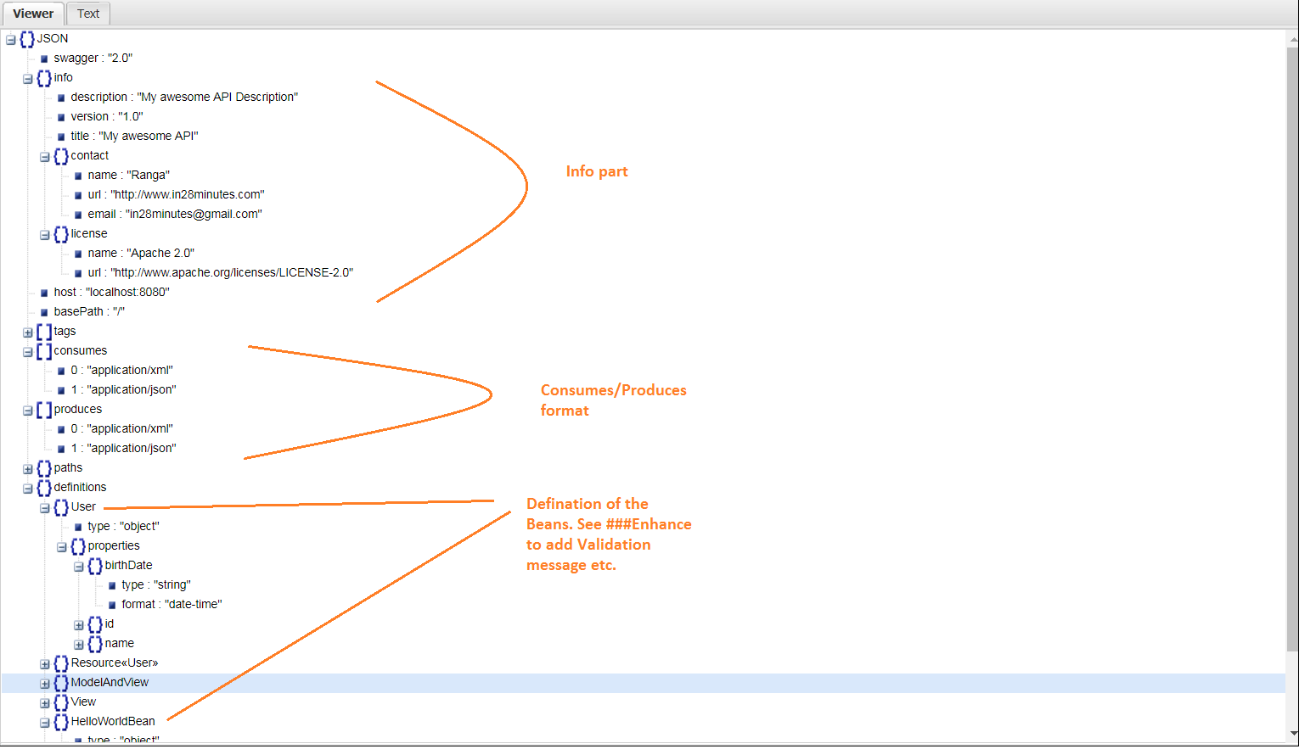

###Enhance:

Use the below annotations on the bean:

@ApiModel(description="All Details about the user") → Bean description

@ApiModelProperty(notes="Name should at least be 2 character & max of 50 charater")

→ attribute validation

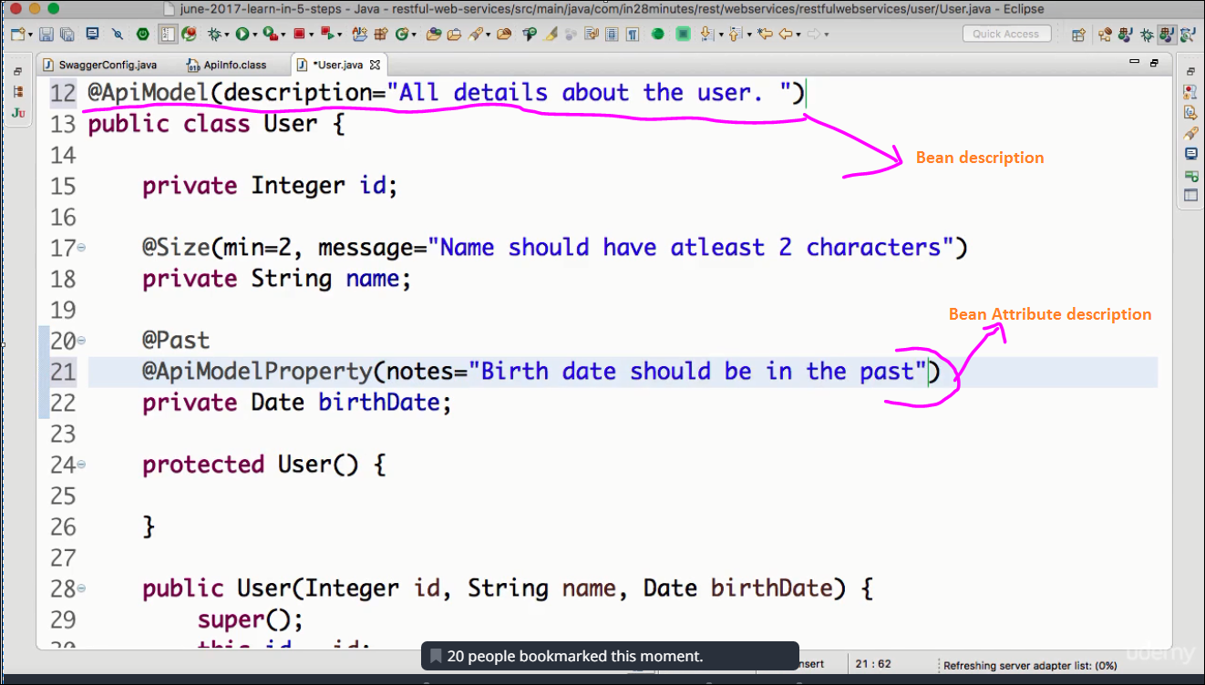

Check out the swagger annotations below:

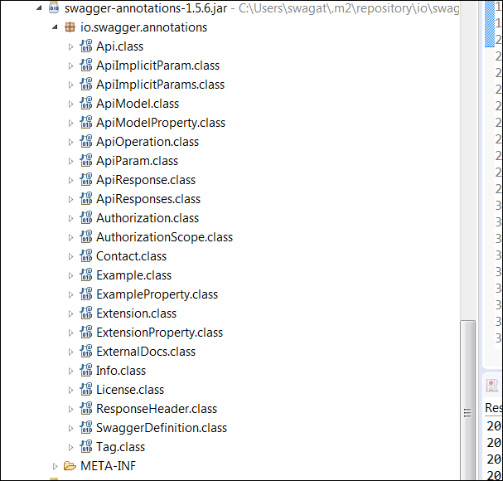

**Lecture 35: Monitoring API with --- Spring Boot Actuator**

1. Add dependency in pom.xml

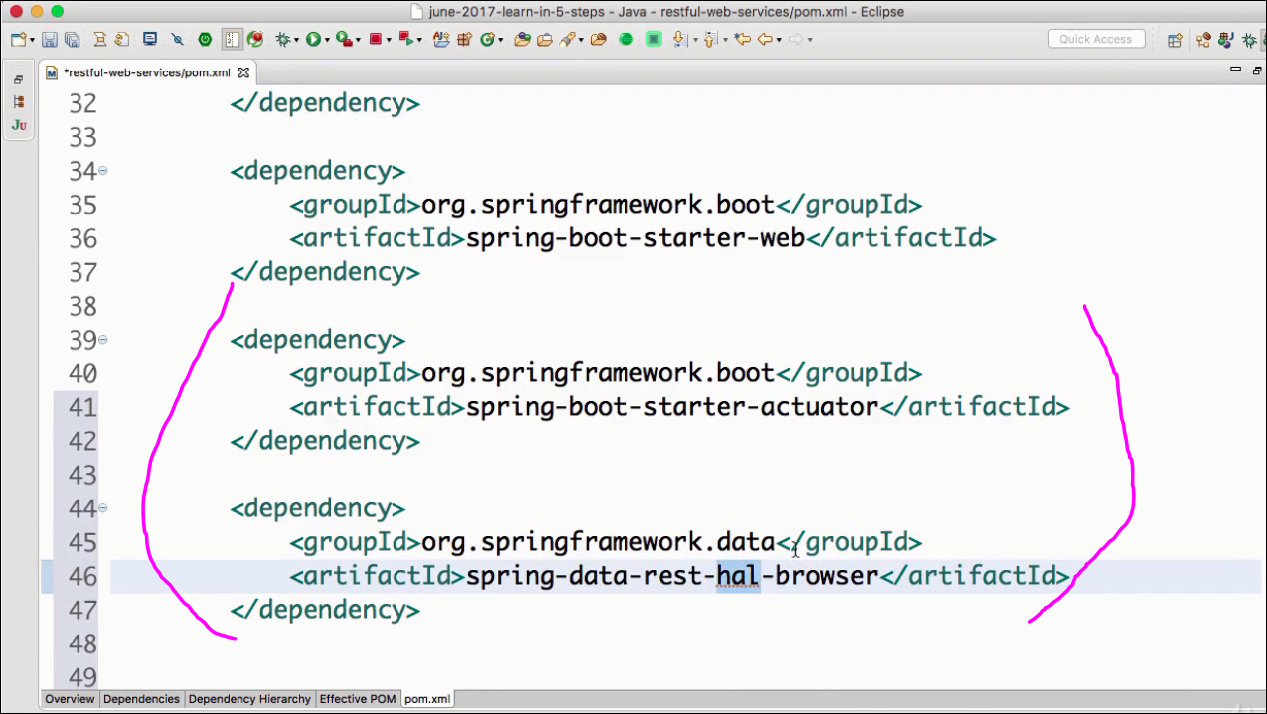

starter-actuator is for → monitoring health/matrices

hal-browser-→ for interpreting the actuator info. HAL => Hypertext Application Language

Ref: <http://stateless.co/hal_specification.html>

2. Restart the application

3. Check the URL :<http://localhost:8080/actuator>

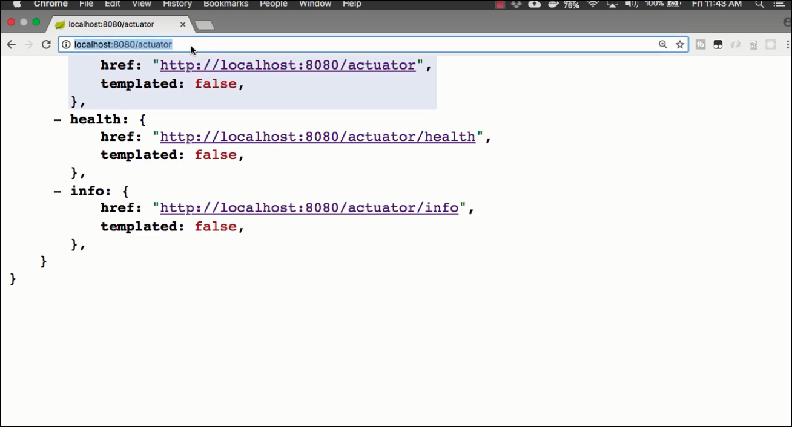

When visited these 3 links:

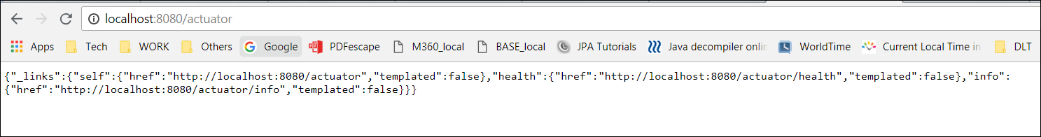

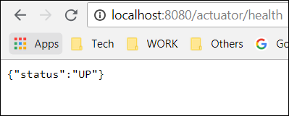

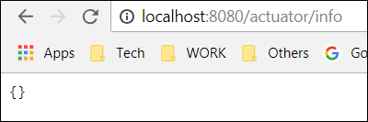

To populate the actuator with all api info, add the below lone in **application.properties**.

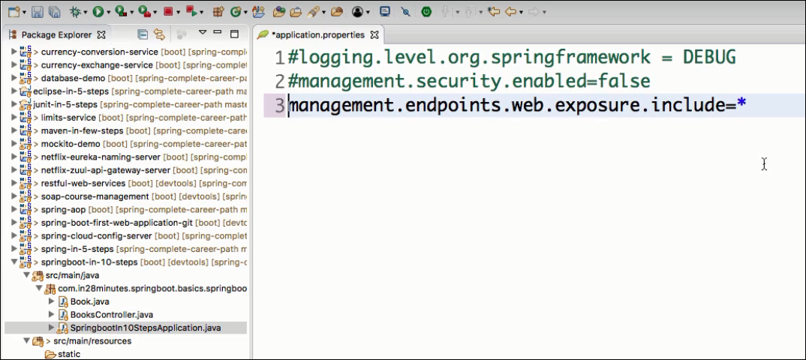

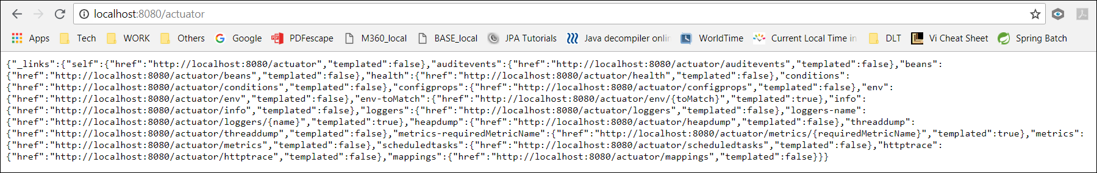

Now lets use the HAL-Browser to see the output:

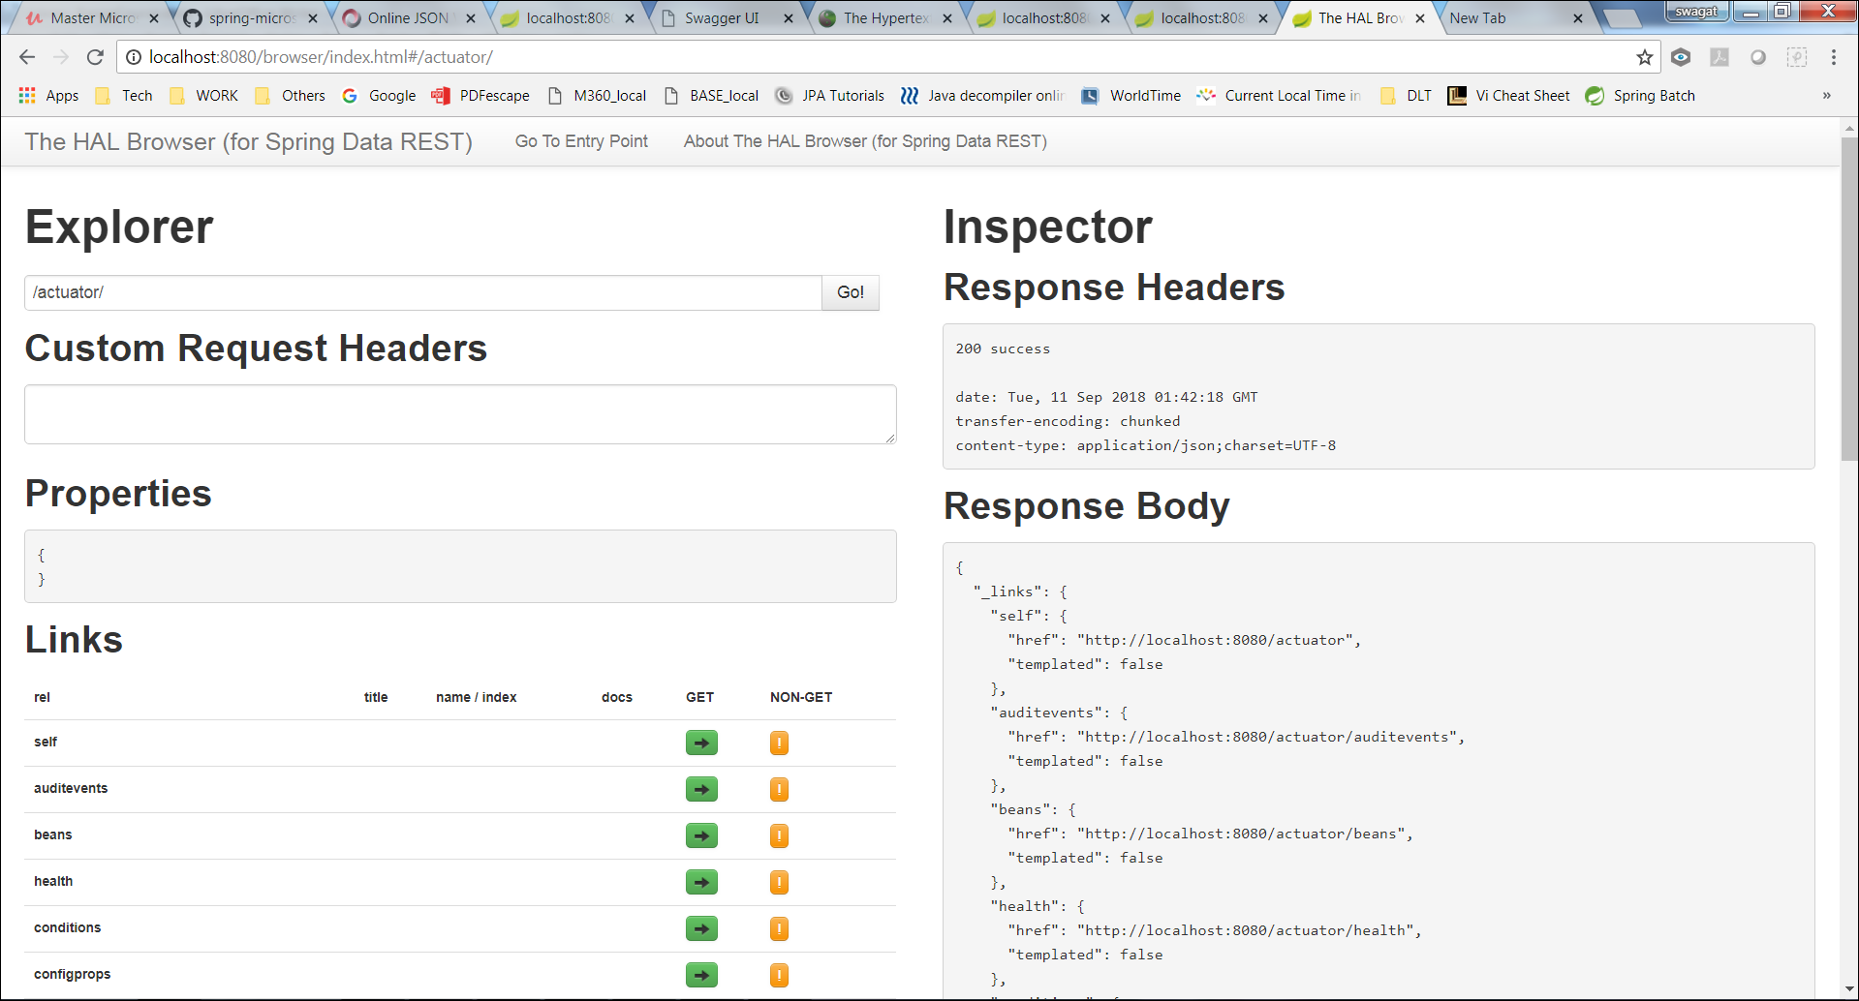

**Lecture 36: Implementing Static filter**

Ignoring few attributes to tbe send in the response.Ex- Password fields, SSN,USCIS passcode etc.

Step1: Write the controllers/mappings as usual

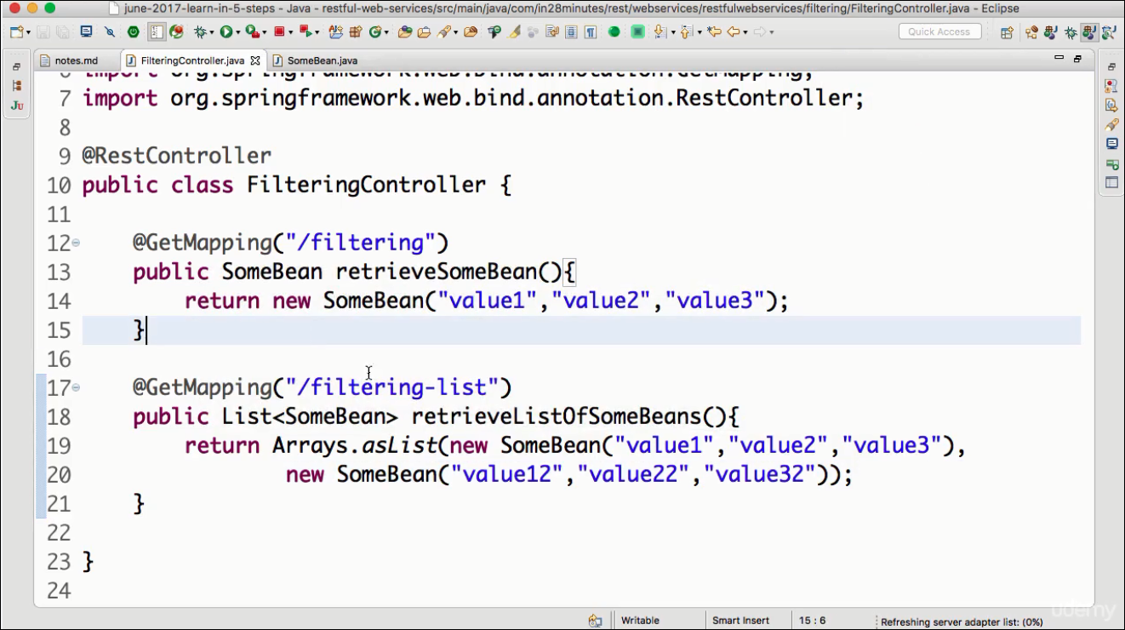

Step2:

Approach1: annotate at attribute level

@JsonIgnore ← annotate the field with this attribute.

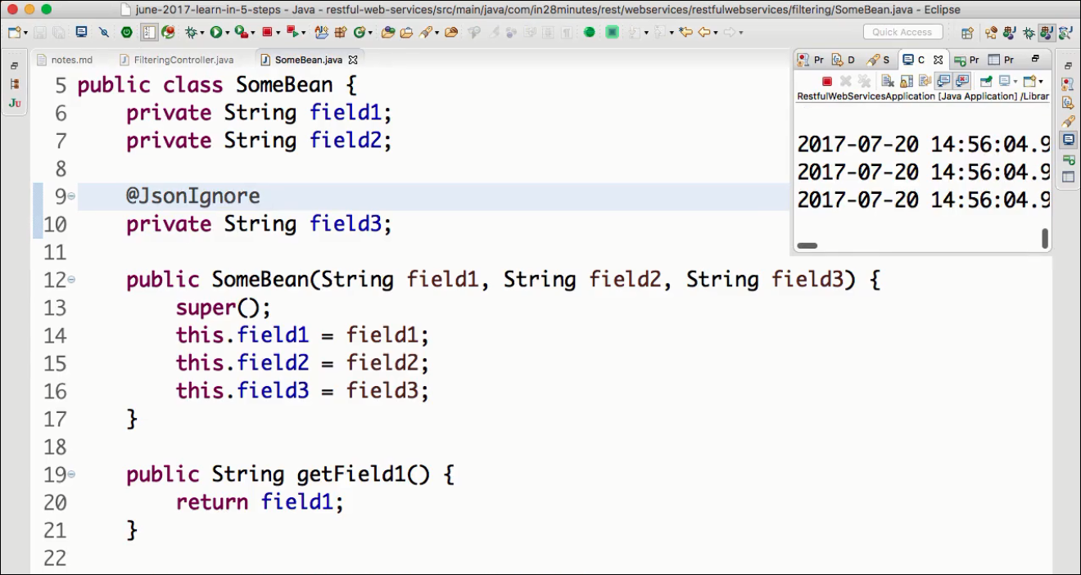

Approach2: annotate at class level

@JsonIgnoreProperties ← pass the list of fields to be ignored

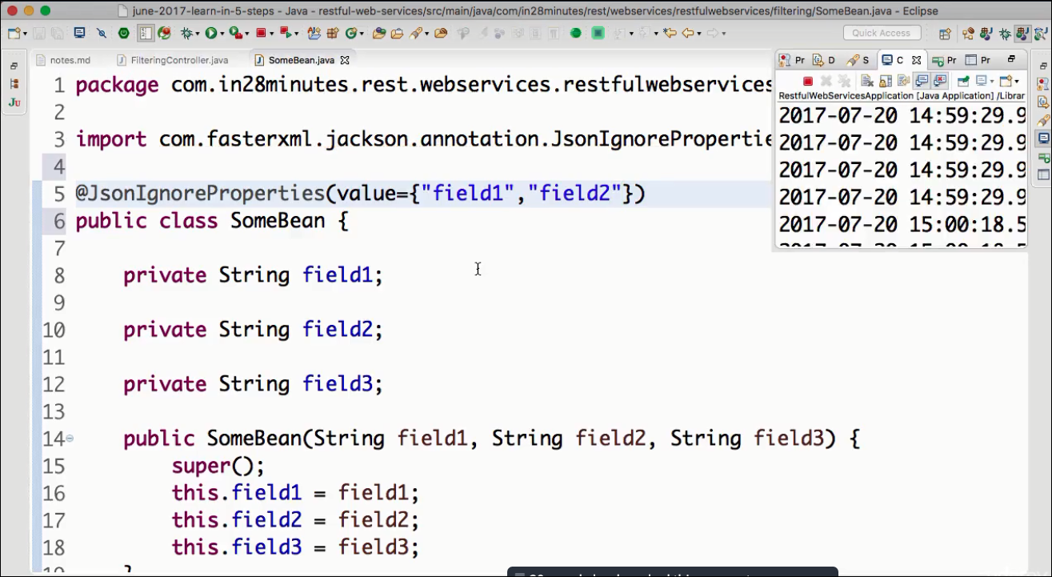

Step3: Test on postman rest client

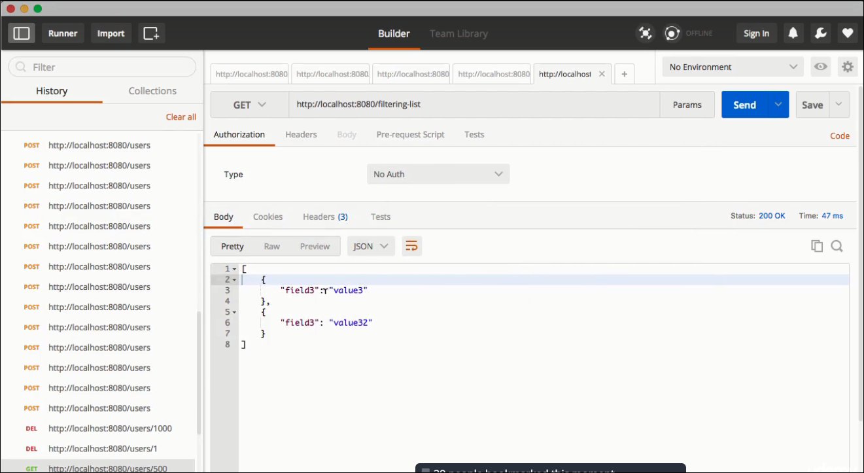

**Lecture 37: Implementing Dynamic filter**

Used to filter few fields from response for some rest mapping & few other fields for some other rest mapping.

Step1:

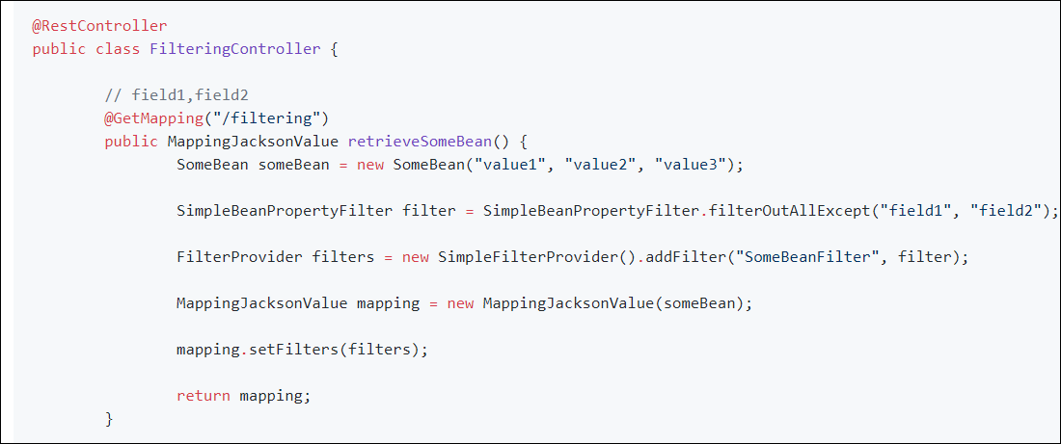

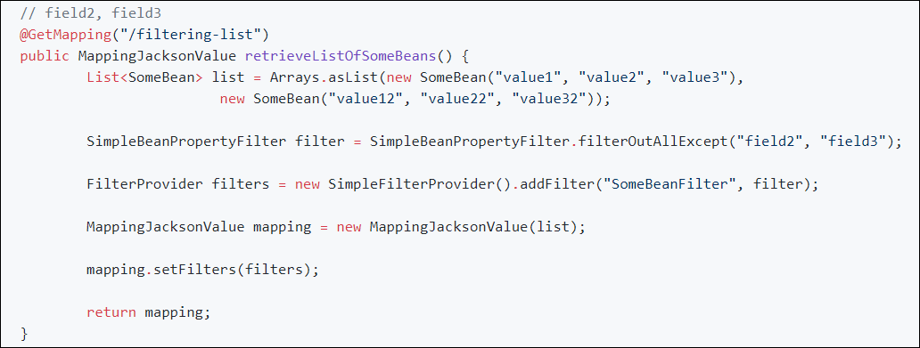Step2: Map the filter to the bean also.

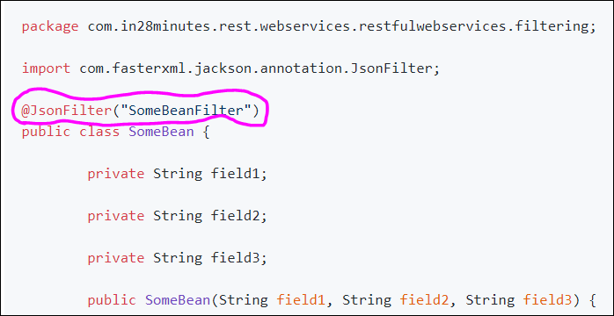

Step3: Test

